**Year 10 Physics End of Topic Test**

**Name: \_\_\_\_\_\_\_\_\_\_\_\_\_\_\_\_\_\_\_\_\_\_\_\_\_\_\_ /39**

**Formula you may need**

[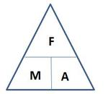](http://www.google.com.au/url?sa=i&rct=j&q=force+mass+acceleration+triangle&source=images&cd=&cad=rja&docid=O6V53PkQA165NM&tbnid=vhNrW-efYEJTlM:&ved=0CAUQjRw&url=http://jdevlin.pottsgrove.wikispaces.net/Physics+Tasks+2012&ei=z6IRUqS2NYyXkgXUoIDwCg&psig=AFQjCNGaoVG_TT9V-bDQMdMZk8qwyYJa6Q&ust=1376973888721903)[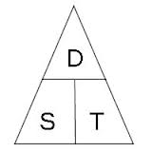](http://www.google.com.au/url?sa=i&rct=j&q=speed%20distance%20time%20triangle&source=images&cd=&cad=rja&docid=l-Td1q_Q0MI0IM&tbnid=cC1NHwB6_ZXB3M:&ved=0CAUQjRw&url=http://www.skoool.co.za/studynotes/maths/id270.htm&ei=haIRUr72K8GHkQX8qoHACw&psig=AFQjCNFf-ofXYSPuXljl_uBwHvbcdC6D5A&ust=1376973815450016)

[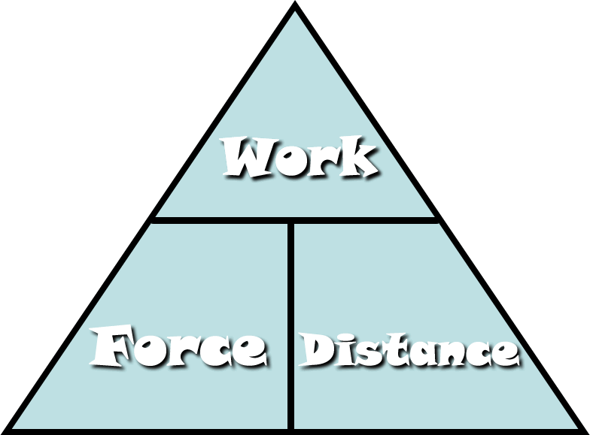](http://www.google.com.au/url?sa=i&rct=j&q=work+force+distance+triangle&source=images&cd=&cad=rja&docid=Fi7mPF8FJi6IOM&tbnid=aV4S5kcpYVNcwM:&ved=0CAUQjRw&url=http://fhm.fhsd.k12.mo.us/jhughes/Hughes/Units/Work&MachinesContent.htm&ei=0aMRUtjOGYyXkgXUoIDwCg&psig=AFQjCNG-nrT1bFGRuWdPLe1VAUwfrjBuYQ&ust=1376974154992588)

[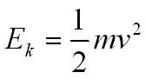](http://www.google.com.au/url?sa=i&rct=j&q=kinetic+energy+formula&source=images&cd=&cad=rja&docid=BZzVErZRq5TMSM&tbnid=KgZmomeJCTMjHM:&ved=0CAUQjRw&url=http://physicsnet.co.uk/a-level-physics-as-a2/mechanics/conservation-of-energy/&ei=UaQRUtzjCsi9kQXBxoGIDQ&psig=AFQjCNH3mfN8ppal1Ay4KsML7bw7tdoQKA&ust=1376974264173183)[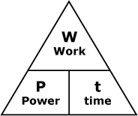](http://www.google.com.au/url?sa=i&rct=j&q=power+woek+time+triangle&source=images&cd=&cad=rja&docid=smEqr3_xk2x1UM&tbnid=FClwhBw-QCE5sM:&ved=0CAUQjRw&url=http://courses.learn60.ca/mod/book/tool/print/index.php?id=18292&ei=DKQRUvmSBoH-kgXw5oDYCg&psig=AFQjCNGFckk2PLfTo6F-_nHw8K9GjonyFA&ust=1376974213287723)

Ek = ½ ms2

[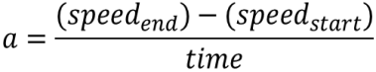](http://www.google.com.au/url?sa=i&rct=j&q=formula+acceleration&source=images&cd=&docid=n1BQvXMu3V1gnM&tbnid=tyy5e7co4fxZgM:&ved=0CAUQjRw&url=http://www.etorgerson.net/WebPages/ScienceUnits/A04_Acceleration.html&ei=ivH1UbrJMIiPkwW0pYD4Bg&psig=AFQjCNGKaO8mY3zS4cauOZdzzpsrQErjaw&ust=1375159034805046)

[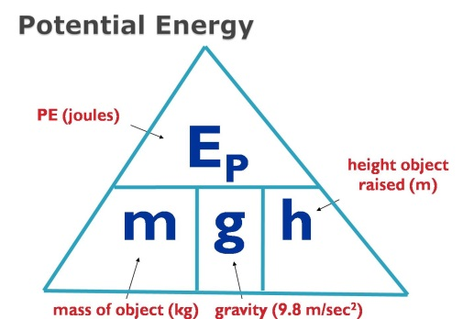](http://www.google.com.au/url?sa=i&rct=j&q=potential+energy+formula&source=images&cd=&cad=rja&docid=2H-GFaF9wBc-AM&tbnid=AD-1C8B0bBkYWM:&ved=0CAUQjRw&url=https://www.allthink.com/v/potentialenergy&ei=hqQRUs2qJsiNkAWSp4DICQ&psig=AFQjCNFHln3I7-BEBHAERUecIisFWqbMGw&ust=1376974319301500)

**Multiple Choice Answer Sheet – Select ONE answer for each**

1. A B C D

2. A B C D

3. A B C D

4. A B C D

5. A B C D

6. A B C D

7. A B C D

8. A B C D

9. A B C D

10. A B C D

11. A B C D

12. A B C D

13. A B C D

14. A B C D

15. A B C D

16. A B C D

17. A B C D

18. A B C D

19. A B C D

20. A B C D

[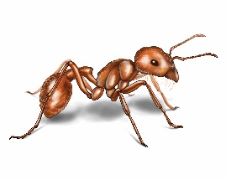](http://www.google.com.au/url?sa=i&rct=j&q=ant&source=images&cd=&cad=rja&docid=xnY1A86yla2paM&tbnid=RzulS6ugMKx4fM:&ved=0CAUQjRw&url=http://www.orkin.com/ants/harvester-ant/&ei=dZs7UrXWFNDDkAWDrIHoDA&psig=AFQjCNH_SG2m2KFbnhWkRaDTwREnye2S-g&ust=1379724529024052)**1** What distance would an ant, crawling at a speed of 2 centimetres per second, cover in an hour? (Distance = Speed x Time)

A 120 cm

B 7200cm

C 1200m

D 7200m

**2** Two forces stretch a cable within a structure. Which of the following best describes the cable?

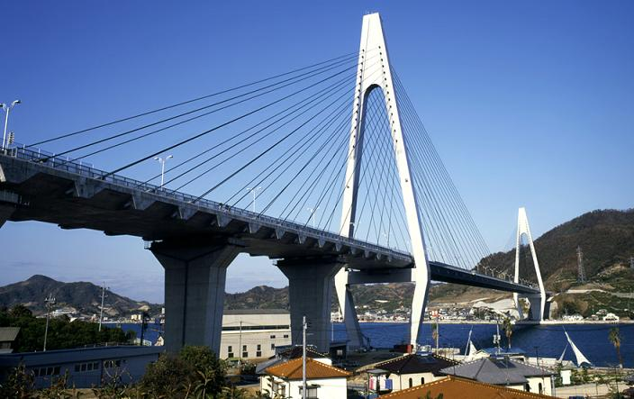

Cables

A The cable is in compression.

B The cable is in tension.

C The cable is being stretched by gravity.

D The cable is unbalanced.

[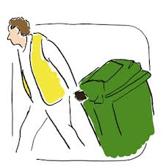](http://www.google.com.au/url?sa=i&rct=j&q=put+out+wheely+bin&source=images&cd=&cad=rja&docid=29pzR1WcQ3u_eM&tbnid=3Co3y0nBE_mw2M:&ved=0CAUQjRw&url=http://www.oxfordshire.gov.uk/cms/content/rubbish-and-recycling-oxfordshire&ei=g9A7UsKpCIKIkwWw6YH4Dg&psig=AFQjCNGHJ3ZxsU6cRHbs3zRqdJid1aroRw&ust=1379738041806358)**3** Chris applies a 90 N to a 65 kg bin. The bin will accelerate at: $(A=\frac{Force}{Mass} )$

A 0.138 m/s2

B 1.38 m/s2

C 5850 m/s2

D 58.5 m/s2

**4** Power is the rate at which energy is supplied. What power is needed to supply 6000 J to lift a 15kg child 10 m up a vertical cliff face in 5 seconds? $\left(Power= \frac{Work}{Time}\right)$

A 1200 J/s

B 120 J/s

C 300 000 J/s

D 30 000 J/s

**5** Look at the three pieces of ticker tape below, labelled A, B and C.

Choose the answer that explains each piece correctly.

[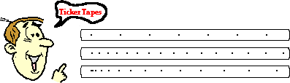](http://www.google.com.au/url?sa=i&rct=j&q=ticker+tape+speed&source=images&cd=&cad=rja&docid=wMhrNsjROP9a0M&tbnid=vzACHjSPZdrteM:&ved=0CAUQjRw&url=http://www.nileswestils.com/ILS/Acceleration.html&ei=-tA7UrGqKIfdkgXOt4HIBA&psig=AFQjCNH19iGDLCD5X9W_FaHQYkKvniD58g&ust=1379738197384806)

**A**

**B**

**C**

|  |  |  |  |
| --- | --- | --- | --- |
|  | Piece A | Piece B | Piece C |
| A | Decelerating | Maintaining a constant speed | Accelerating |
| B | Maintaining a constant speed | Accelerating | Decelerating |
| C | Accelerating slowly | Maintaining a constant speed | Decelerating |
| D | Maintaining a constant Speed | Accelerating Slowly | Accelerating faster |

**6** When a door or window sticks it indicates that the structure:

A has partly failed

B has forces acting on it

C has all of its forces balanced

D has no forces acting on it

**7** An aircraft is flying in a straight line at constant altitude and at a constant speed. What can be said about the forces on the aircraft?

A The forces are unbalanced.

B The forces are balanced.

C The forces are compression forces.

D The aircraft is accelerating.

**8** When standing, your legs are in:

A compression

B tension

C failure

D friction

**9** A cable was placed under tension until just before it broke. Which of the following diagrams best shows the cable just before it broke?

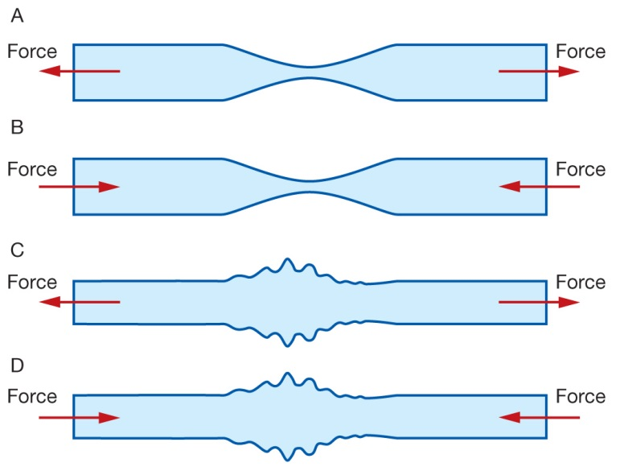

**10** The Bridge (diagram below) is an example of a: [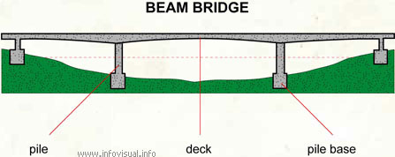](http://www.google.com.au/url?sa=i&rct=j&q=beam%20bridge&source=images&cd=&cad=rja&docid=I-xSqF0PU79-9M&tbnid=9SfHeT76u1K29M:&ved=0CAUQjRw&url=http://www.infovisual.info/05/030_en.html&ei=hhxFUsqbGsOKlQWfnYGQDA&psig=AFQjCNFNUrQOaz3GxlpviXKFtYWnzFtkdw&ust=1380347350129093)

A bowstring arch bridge

B cable-stayed bridge

C suspension bridge

D beam bridge

**[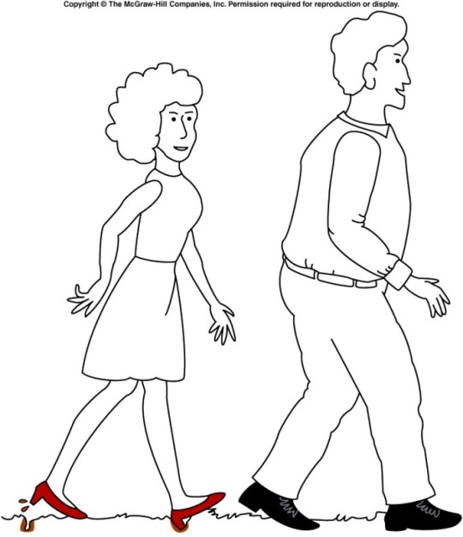](http://www.google.com.au/url?sa=i&rct=j&q=pressure+high+heel&source=images&cd=&cad=rja&docid=nxP8BgFtQrkhwM&tbnid=dVIUZoWEAPzlTM:&ved=0CAUQjRw&url=http://onlinephys.com/pressure.html&ei=hfU3Uoq9C8WfkwW2toHQAg&psig=AFQjCNGIEB4RESz64D3f84yVrSv_95GNLw&ust=1379485420790197)11** Which of the following is **true** about the diagram of the man and woman walking?

A The woman is making marks in the ground because she is placing more force on the grass

B The man is not making any marks on the ground because he is placing less force on the grass

C The woman is making marks on the ground because her shoes have less area touching the ground

D The man’s shoes are not making any marks on the ground because his have less area touching the ground

**12** Which of the following has kinetic energy?

A A bike parked on a hill.

B A child running.

C A stretched balloon.

D A bumblebee hovering in the same spot.

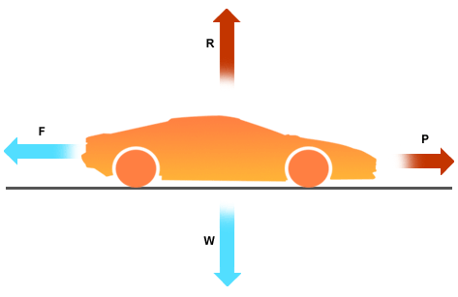

**13** Which of the following is **correct** about the movement of the car?

A The car is still

B The car is at a constant speed

C The car is accelerating

D The car is decelerating

[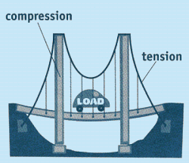](http://www.google.com.au/url?sa=i&rct=j&q=tension+and+compression+structure&source=images&cd=&cad=rja&docid=G3lxRbpcGNLJsM&tbnid=oJ5zGxfMkpJX2M:&ved=0CAUQjRw&url=http://www.carondelet.pvt.k12.ca.us/Family/Math/03210/page4.htm&ei=V9c7UomxLYzFkwXF-IDIAw&psig=AFQjCNEYORpIxQY7OLCRETbBpZif83rsvA&ust=1379739804442263)

**14** Which of the following is **true** about this diagram of a bridge?

**A**

A A shows an area under compression and B shows an area under tension

**B**

B A shows an area under tension and B shows an area under compression

C Both A and B are under tension

D Both A and B are under compression.

**15** Leslie runs a race that starts and finishes at the same point. If the race was 1000 metres, what was Leslie’s displacement at the end of the race?

A 1000 metres

B 500 metres

C 10 metres

D 0 metres

**16** Which of the following is **not** an example of potential energy?

A A bike parked on a hill.

B A skateboard moving down a hill

C A stretched balloon.

D A ball balanced at the top of a slide

1. **17**  Which of the following stick people would be unstable and most likely to topple over?

|  |  |  |  |
| --- | --- | --- | --- |
| A | PSCI_10PR_9_12Ta | B | PSCI_10PR_9_12Tb |
| C | PSCI_10PR_9_12Tc | D | PSCI_10PR_9_12Td |

**18.** Look at the data in this table.

|  |  |
| --- | --- |
| Type of car | Time taken to reach 100km/h from rest (minutes) |
| Ariel Atom V8 | 2.5 |
| Nissan GTR | 3 |
| [Lamborghini Aventador](http://news.drive.com.au/drive/motor-news/first-drive-lamborghini-aventador-20110602-1fhci.html) | 2.9 |

Of the cars in the table above which has the fastest acceleration?

(a) Ariel Atom V8.

(b) Nissan GTR.

(c) Lamborghini Aventador.

(d) This question cannot be answered with the information in the table.

*Questions 19 and 20 refer to the diagram on the right:*

*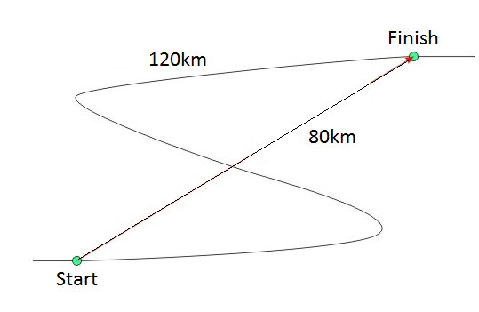***19.** The distance travelled is:

(a) 120km.

(b) 40km.

(c) 80km.

(d) 200km.

**20.** Choose the correct statement below.

(a) The distance is greater than the displacement.

(b) The displacement is greater than the distance.

(c) The distance and displacement are the same.

(d) The displacement is sometimes a straight line distance and direction.

**Short Answer**

**1** Classify the following as situations in which forces are balanced or unbalanced: (4 Marks)

a) A motorbike is accelerating away from traffic lights. \_\_\_\_\_\_\_

b) A car is travelling at 100 km/h straight down a freeway. \_\_\_\_\_\_

c) A surfer falls off their surfboard. \_\_\_\_\_\_

d) A bird flies into a window and bounces off. \_\_\_\_\_\_\_

**2.** Construct diagrams showing forces: (2 Marks)

a) In compression

b) In tension.

**3.** When a structure fails, it doesn’t always fall down. List two ways you can tell that some minor failure has occurred in a structure. (2 Marks)

**4.** Mr Lafferty walked around the park as shown in the diagram below.

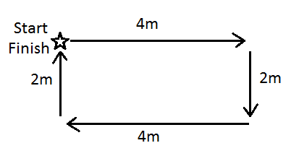

a) Calculate Mr Lafferty’s distance. (1 mark)

\_\_\_\_\_\_\_\_\_\_\_\_\_\_\_\_\_\_\_\_\_\_\_\_\_\_\_\_\_\_\_\_\_\_\_\_\_\_\_\_\_\_\_\_\_\_\_\_\_\_\_\_\_\_\_\_\_\_\_\_\_\_\_\_\_\_\_\_\_\_\_\_\_\_\_\_\_\_\_\_\_

b) Calculate Mr Lafferty’s displacement. (1 mark)

\_\_\_\_\_\_\_\_\_\_\_\_\_\_\_\_\_\_\_\_\_\_\_\_\_\_\_\_\_\_\_\_\_\_\_\_\_\_\_\_\_\_\_\_\_\_\_\_\_\_\_\_\_\_\_\_\_\_\_\_\_\_\_\_\_\_\_\_\_\_\_\_\_\_\_\_\_\_\_\_\_

**5.** Jade rides her bike with a constant speed of 7m/s. It takes 240 seconds to get to school. Calculate how far away school is. (2 marks)

**SHOW ALL OF YOUR WORKING OUT.**

Distance= average speed x time d = v x t

d= v= t=

**6.** This table shows the speed of a man driving a car over time.

|  |  |
| --- | --- |
| **Speed of car (m/s)** | **Time (s)** |
| 5 | 2 |
| 30 | 4 |
| 28 | 6 |
| 10 | 8 |
| 5 | 10 |

Draw a graph using the information from the table above. (5 marks)

REMEMBER all the things that a graph needs!

[](http://www.google.com.au/url?sa=i&rct=j&q=graph+paper&source=images&cd=&cad=rja&uact=8&docid=bnDyK-WDEHhooM&tbnid=OH_xw5ZTcFEuvM:&ved=0CAUQjRw&url=http://virtualmathtutor.blogspot.com/2010/11/how-to-draw-circle-without-compass.html&ei=RKw4U5fxF8fClQWCrIGoCQ&psig=AFQjCNHahbsWAgdANQM5RZCXw4z48cLLBw&ust=1396309252654415)

Describe what happened to the car over the time period. (2 marks)

\_\_\_\_\_\_\_\_\_\_\_\_\_\_\_\_\_\_\_\_\_\_\_\_\_\_\_\_\_\_\_\_\_\_\_\_\_\_\_\_\_\_\_\_\_\_\_\_\_\_\_\_\_\_\_\_\_\_\_\_\_\_\_\_\_\_\_\_\_\_\_\_\_\_\_\_\_\_\_\_\_\_\_\_\_\_\_\_\_\_\_\_\_\_\_\_\_\_\_\_\_\_\_\_\_\_\_\_\_\_\_\_\_\_\_\_\_\_\_\_\_\_\_\_\_\_\_\_\_\_\_\_\_\_\_\_\_\_\_\_\_\_\_\_\_\_\_\_\_\_\_\_\_\_\_\_\_\_\_\_\_\_\_\_\_\_\_\_\_\_\_\_\_\_\_\_\_\_\_\_\_\_\_\_\_\_\_\_\_\_\_\_\_\_\_\_\_\_\_\_\_\_\_\_\_\_\_\_\_\_\_\_\_\_\_\_\_\_\_\_\_\_\_\_\_\_\_\_\_\_\_\_\_\_\_\_\_\_\_\_\_\_\_\_\_\_\_\_\_\_\_\_\_\_\_\_\_\_\_\_\_\_\_\_\_\_\_\_\_\_\_\_\_\_\_\_\_\_\_\_\_\_\_\_\_\_\_\_\_\_\_\_\_\_\_\_\_\_\_\_\_\_\_\_\_\_\_\_\_\_\_\_\_\_\_\_\_\_\_\_\_\_\_\_

**SOLUTIONS**

**Multiple Choice Answer Sheet**

1. A B C D

2. A B C D

3. A B C D

4. A B C D

5. A B C D

6. A B C D

7. A B C D

8. A B C D

9. A B C D

10. A B C D

11. A B C D

12. A B C D

13. A B C D

14. A B C D

15. A B C D

16. A B C D

17. A B C D

18. A B C D

19. A B C D

20. A B C D

**Short Answer**

**1.** Classify the following as situations in which forces are balanced or unbalanced: (4 Marks)

a A motorbike is accelerating away from traffic lights. Unbalanced

b A car is travelling at 100 km/h straight down a freeway. Balanced

c A surfer falls off their surfboard. Unbalanced

d A bird flies into a window and bounces off. Unbalanced

**2.** Construct diagrams showing forces: (2 Marks)

a in compression

Arrows pointing to each other

b in tension.

Arrows pointing away from each other

**3.**  When a structure fails, it doesn’t always fall down. List two ways you can tell that some minor failure has occurred in a structure. (2 Marks)

Any 2 reasonable answers

**4.** Mr Lafferty walked around the park as shown in the diagram below.

a) Calculate Mr Lafferty’s distance. (1 mark)

12m (0.5 for 2 , 0.5 for m)

b) Calculate Mr Lafferty’s displacement. (1 mark)

2m North (0.5 for 2m, 0.5 for North)

**6.** Jade rides her bike with a constant speed of 7m/s. It takes 240 seconds to get to school. Calculate how far away school is. (2 marks)

**SHOW ALL OF YOUR WORKING OUT.**

Distance= average speed x time d = v x t

d= ? v= 7m/s t= 240 seconds

d = v x t

d = 7 x 240

d = 1680m

**7.** This table shows the speed of a man driving a car over time.

-1 mark (not in pencil)

-1 mark (not with ruler)

-1 mark (inappropriate title)

-1 mark (axis mixed up)

-1 mark (missing units of measurement)

-1 mark (wrong type of graph)

Speed of Car versus Time

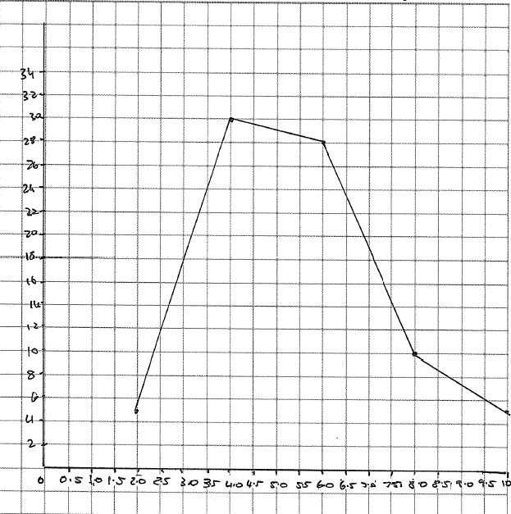

Speed of Car (m/s)

Time (Seconds)

The car speeds up quickly at 4 seconds and then slows down again at 8 seconds (2 marks)